Introduction
This project is making self balancing robot. Here is all the design information for this project.

System diagram
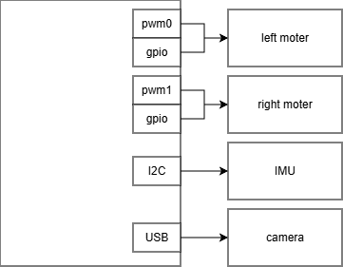
Figure 1. System diagram

Pin definition
Name | Functionality | Pin
I2C SDA | IMU | GPIO2
I2C SCL | IMU | GPIO3
DRDY | IMU ready pin | GPIO17
PWM Left | Left motor pwm | GPIO18
PWM Right | Right motor pwm | GPIO19
DIR Left | Left motor Direction | GPIO23
DIR Right | Right motor Direction | GPIO24
DIR Left 2 | Left motor Direction | GPIO27
DIR Right 2 | Right motor Direction | GPIO22
STBY |  | GPIO25
Left ENC A | Left motor encoder A | GPIO5
Left ENC B | Left motor encoder B | GPIO6
Right ENC A | Right motor encoder A | GPIO13
Right ENC B | Right motor encoder B | GPIO26

Task definition
Rt control: implement PID / LQR control algorithm, get state from encoder and imu, and then PWM to the motor driver.
IMU task: Reading the accelerate from IMU, store data in buffer.
Encoder task: Reading the gpio state of A and B phase. Calculate the angular speed of motor.

Task dispatch
Rt control is in cpu0.
IMU task is in cpu1.
Encoder task is in cpu2.

Task flow chart

Rt control

Encoder

IMU

Design specification
The control loop period is 200 Hz.

